**Environmental Information Regulation Request - Humberside Fire and Rescue Service**

**2024/25 056 – Fire Hydrant Location, Scunthorpe**

**The request is:**

I would like to make an Environmental Information Regulation Request for the answers to the below questions.

Please would you provide information of the closest hydrants to the following site: **Unit 6, Normanby Road, Scunthorpe, DN15 8QZ.** National Grid Reference: **SE 89028 13966.**

I have included a capture of the site location below with the approximate boundary highlighted in green.

Please would you also confirm if the hydrants are in accordance with BS 750 and are able to deliver a flow rate of 2,000 litres per minute.

**The response is:**

Please see the below screen shot of fire hydrant locations. The nearest to unit six is at grid reference 488973-413974

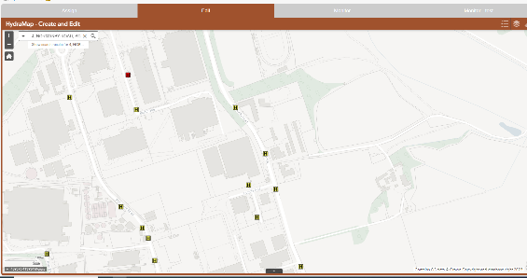

Fire hydrants in this area are installed by Anglian Water and are compliant with the relevant British Standard at time of installation. The flow rate is not something we test, and we do not therefore hold this information. Any information relating to the flow rates from fire hydrants should be directed to Anglian Water.

We work to the following Water UK document, National Guidance Document on the Provision of Water for Firefighting which states:

*In line with the National Guidance Document on the Provision of Water for Firefighting, Fire and Rescue Services and Water Companies are encouraged to move away from the flow testing of hydrants and use other methodologies. This is not seen as a test for maintaining a hydrant and, for the reasons highlighted in Section 3, there is little purpose to this test. As a result, the flow test is not included in the recommended hydrant inspection and testing methodology.*

If you are unhappy with the handling of your request, you have the right to ask for an internal review. A request for an internal review should be made within 40 working days of the date of this email. If you are not happy with the outcome of the internal review, you have the right to apply direct to the Information Commissioner. The address is: Information Commissioner’s Office, Wycliffe House, Water Lane, Wilmslow, Cheshire SK9 5AF.

[https://ico.org.uk/](https://ico.org.uk/#_blank)