Freedom of Information - Humberside Fire and Rescue Service (HFRS)
2024-25/011 – Electrical Safety
The request is:
I would like to submit as FOI request, on behalf of Electrical Safety First
Attached to this email are seven short questions, which we hope will be relatively straightforward for you to reply to – if there are any difficulties, or differences in how you record information, please just share what you can or let me know and we can adjust accordingly. Furthermore, the first four questions are particularly important for our work, so please prioritise these if possible.
- Number of incidences attributed to:
  - Solar PV
  - Battery Storage System
  - Heatpump (Airsource)
  - Heatpump (ground source)
  - Wind turbine
  - Electric Vehicle Charging Equipment
- Number of injuries caused by the incidences in question 1.
- Number of deaths caused by the incidences in question 1.
- What was the cause of the incidences (based on IRS categories)?
    - Faulty Appliances and Leads
    - Misuse of Equipment or Appliances
    - Careless handling of fire or hot substances
    - Deliberate
    - Faulty fuel supplies
    - Placing articles too close to heat
    - Playing with fire
    - Other (please state)
- Can the problems be pinpointed to:
  - User error/lack of understanding of the item /system requirements? (please explain)
  - Installation error? (please explain)
    - Electrical
    - Mechanical / fixing (note: we do need to find if there is an issue with electrical installers breaching roofing construction methods)
  - Design error (please explain)
  - Equipment failure? (please explain)
  - Lack of maintenance of the LCT system and wiring? (please explain)
- Were the affiliated switchgear, and protective devices (e.g., MCB, Fuse, RCBO, RCD, etc), in the consumer unit/distribution board checked to be suitable and correctly sized for the installation, considering the potential increased current flows and bi-directional operation
- What was the age of the installation?

The response is:
Please see information table below containing the information requested. We can accurately answer questions 1-4 however the information requested in questions 5-7 is not recorded within the incident recording system. All of these incidents only had a Level 1 Investigation carried out which means that beyond the general cause of the fire, we would not investigate the specific intricacies of the systems to determine faults. We do not therefore hold this information.
Another incident was listed relating to an electric vehicle charger; however, this was a false alarm with no action taken beyond investigating the smell of burning and isolating the power supply as a precaution. We have not included this incident in the table below.

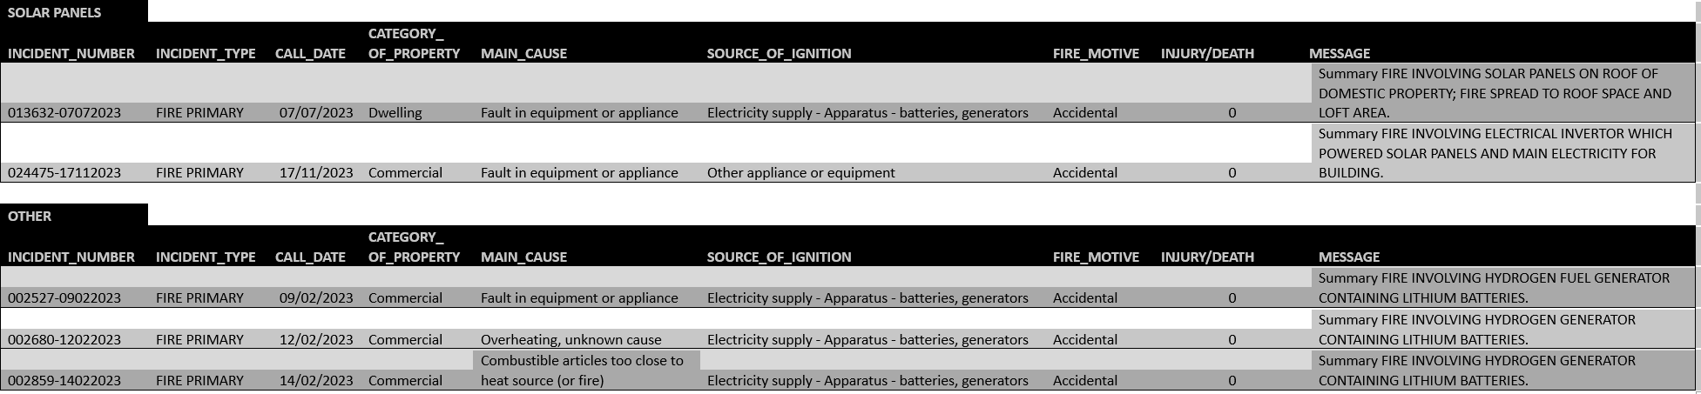

If you are unhappy with the handling of your request, you have the right to ask for an internal review. A request for an internal review should be made within 40 working days of the date of this email. If you are not happy with the outcome of the internal review, you have the right to apply direct to the Information Commissioner. The address is: Information Commissioner’s Office, Wycliffe House, Water Lane, Wilmslow, Cheshire SK9 5AF.
https://ico.org.uk/

