Freedom of Information - Humberside Fire and Rescue Service (HFRS)
2024-25/022 – Assaults Against Firefighters

The request is:
1. How many assaults against firefighters were recorded in each of the last five years, 2019/2020/2021/2022/2023.
2. Could I have a geographic breakdown of where the assaults occurred.
3. Could I have a brief description of the nature of the assault.

The response is:
Please see the attached spreadsheet containing the information you require.
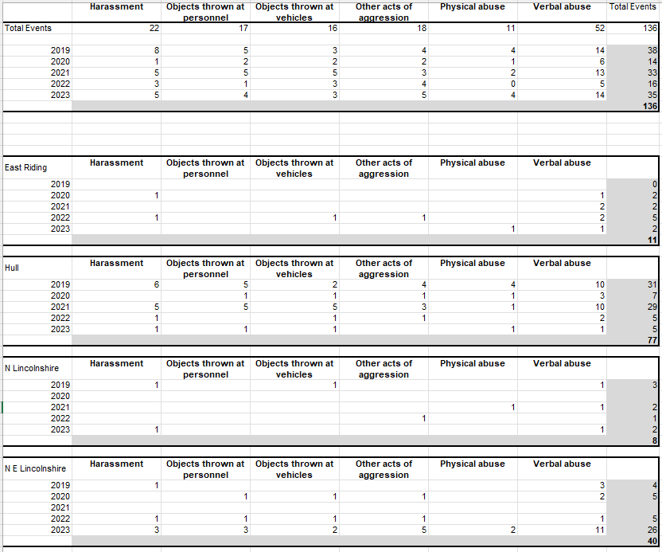

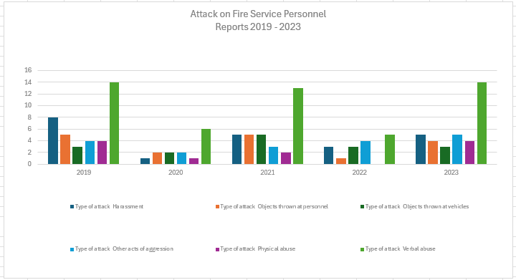

If you are unhappy with the handling of your request, you have the right to ask for an internal review. A request for an internal review should be made within 40 working days of the date of this email. If you are not happy with the outcome of the internal review, you have the right to apply direct to the Information Commissioner. The address is: Information Commissioner’s Office, Wycliffe House, Water Lane, Wilmslow, Cheshire SK9 5AF.
https://ico.org.uk/

