Freedom of Information - Humberside Fire and Rescue Service (HFRS)
2024-25/017 – Fires Involving E-Bikes

The request is:
Between January 2022 and January 2023, how many fires relating to E-Bikes was the service called out to?
Between January 2023 and January 2024, how many fires relating to E-Bikes was the service called out to?
Of these call outs, how many related to serious injury?
Of these call outs, how many led to a fatality?

The response is:
Please see the attached spreadsheet which was issued in response to a recent request and from which you can obtain the information required.
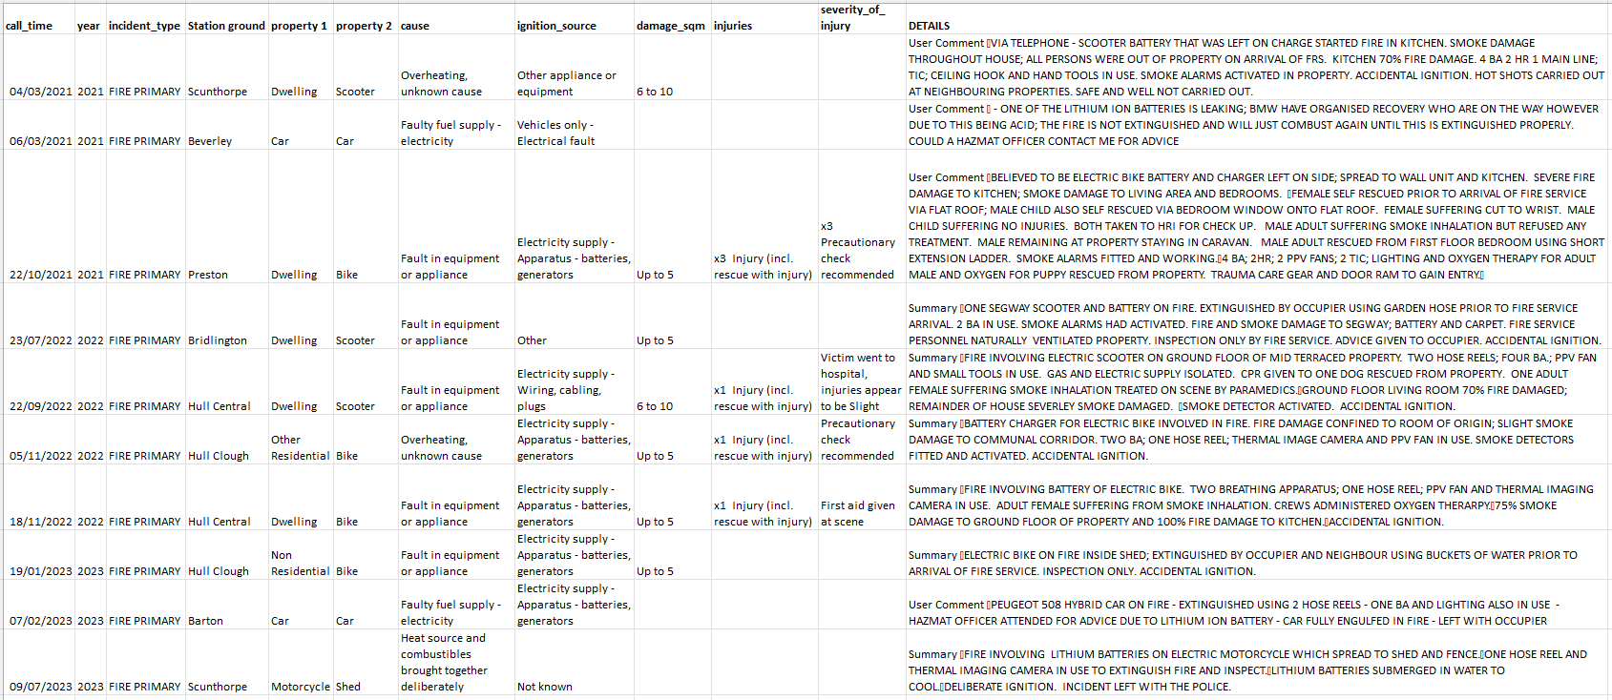

If you are unhappy with the handling of your request, you have the right to ask for an internal review. A request for an internal review should be made within 40 working days of the date of this email. If you are not happy with the outcome of the internal review, you have the right to apply direct to the Information Commissioner. The address is: Information Commissioner’s Office, Wycliffe House, Water Lane, Wilmslow, Cheshire SK9 5AF.
https://ico.org.uk/

