**Humberside Fire and Rescue Service**

**Council Tax Precept 2025/26 Consultation**

For the 2025/26 financial year, we are asking if you would be willing to increase your contributions to help support your fire and rescue service.

Additional funding would allow us to maintain the high standard of services we currently provide, while investing in our plans to make sure we are prepared to meet future needs and risks. This aligns with our Community Risk Management Plan, benefiting everyone across the Humber region and helping to keep us all safe.

Many homes in the Humber region are in lower Council Tax bands, so for most, the proposed increases are smaller.

**Proposed Fire and Rescue Precept for 2025/26**

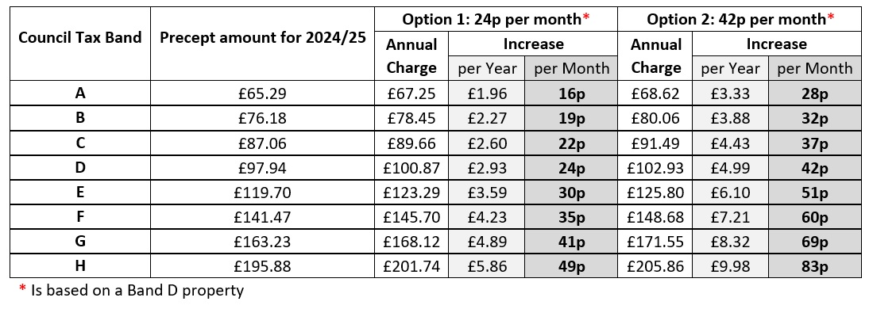

**Take Part Here**

We are asking for your support by selecting **one** out of the fouroptions below:

**Option 1: A £2.93 (2.99%) increase. This is 24p per month (£2.93 per year) on a Band D property.**

**Option 2: A £4.99 (5.09%) increase. This is 42p per month (£4.99 per year) on a Band D property.**

**Option 3: No increase**

**Option 4: An alternative amount.** Please tell us the alternative amount using the box below:

|  |
| --- |
|  |

**Consultation closes at 5 pm on Friday 24 January 2025**. The final precept recommendation will be considered by Humberside Fire Authority at its meeting on 14 February 2025. If you have any questions about the consultation or require it in an alternative format, please email: [corporatecommunication@humbersidefire.gov.uk](mailto:corporatecommunication@humbersidefire.gov.uk)

Return to: [corporatecommunication@humbersidefire.gov.uk](mailto:corporatecommunication@humbersidefire.gov.uk)

Humberside Fire and Rescue Service HQ, Summergroves Way, Hull, HU4 7BB

**About you**

We want to make sure that we are getting responses from our communities across the Humber region and to help us to ensure that we are achieving this, please tell us about yourself.   
**How did you discover the consultation survey?** (Please tick all that apply)

|  |  |  |  |
| --- | --- | --- | --- |
| Humberside Fire and Rescue Website |  | Social media |  |
| Member of staff – face to face |  | Local press |  |
| My Community Alert |  | Staff Newsletter |  |

**Do you work for Humberside Fire and Rescue Service?**

|  |  |  |  |
| --- | --- | --- | --- |
| Yes |  | No |  |

**Which county do you live in?**

|  |  |  |  |
| --- | --- | --- | --- |
| Hull |  | East Riding |  |
| North Lincolnshire |  | North East Lincolnshire |  |
| I live outside of the Humber region |  | If so, please state: | |

**Do you consider yourself to have a disability?**

|  |  |  |  |
| --- | --- | --- | --- |
| Yes |  | No |  |

**What age are you?**

|  |  |  |  |
| --- | --- | --- | --- |
| Under 18 |  | 35 - 44 |  |
| 18 - 24 |  | 45 - 54 |  |
| 25 - 34 |  | 55 - 64 |  |
| 65+ |  | Prefer not to say |  |

**What gender do you identify as?**

|  |  |  |  |
| --- | --- | --- | --- |
| Man |  | Woman |  |
| Non-binary |  | Other |  |
| Prefer not to say |  |

**What ethnicity are you?**

|  |  |  |  |
| --- | --- | --- | --- |
| Asian or Asian British - Bangladeshi |  | Asian or Asian British - Indian |  |
| Asian or Asian British - Pakistani |  | Asian British – Other Asian Background |  |
| Black or Black British - African |  | Black or Black British - Caribbean |  |
| Black or Black British – Other Black Background |  | Chinese |  |
| Mixed – Other Dual Heritage |  | Mixed – White and Asian |  |
| Mixed – White and Black African |  | Mixed – White and Black Caribbean |  |
| White - British |  | White - Irish |  |
| White - Other |  | Prefer not to say |  |